Experiment no:7

Static Routing Analysis using Packet Tracer

Aim:

To establish static routing using packet tracer.

Procedure:

Step 1: Click on end devices, select generic Pc’s drag and drop it on the window. Click on SWITCH drag and drop it on the window. Click on ROUTER drag and drop in on the window.

Step 2: It can contain two routers and connected with two switches and the two switches are again connected with another two pcs. Pc0 and pc1 are connected with switch o and pc2 and pc3 are connected with switch 1.

Step 3: For router0 and router1 we can have to give the IP address and pc0, pc1, pc2, pc3 we can give the IP address. At first we have to give the IP address to router0 and router1 after pc0 and pc1 can have the IP address.

Step 4: After connecting with router to switch and to pcs we can pass the mails from one pc to another.

Step 5: Now display the static routing analysis using packet tracer in simulation mode.

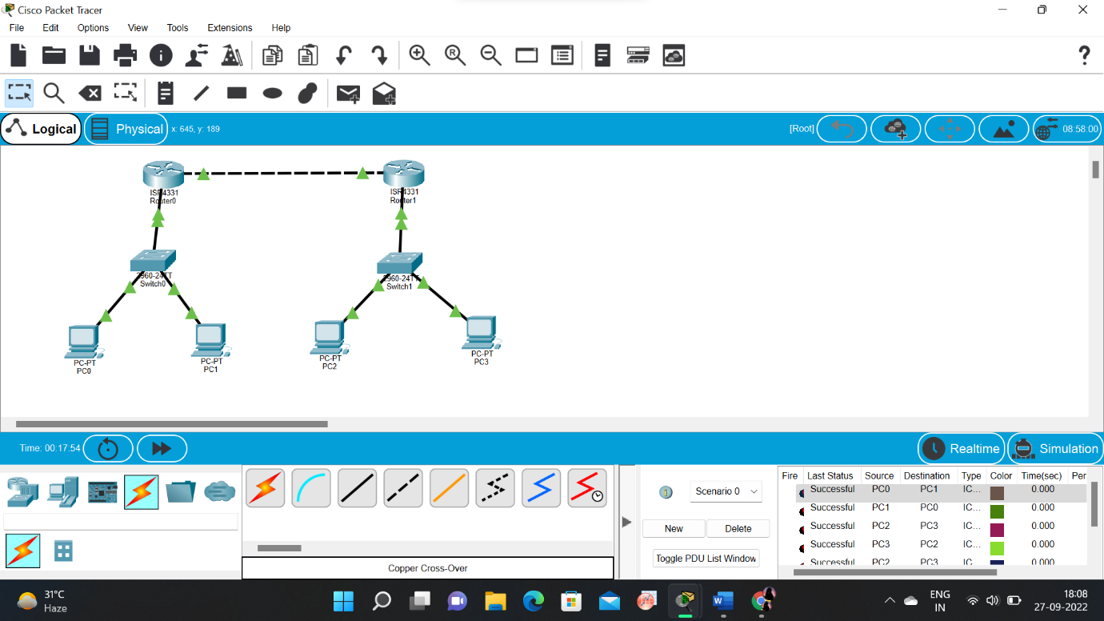Static Routing:

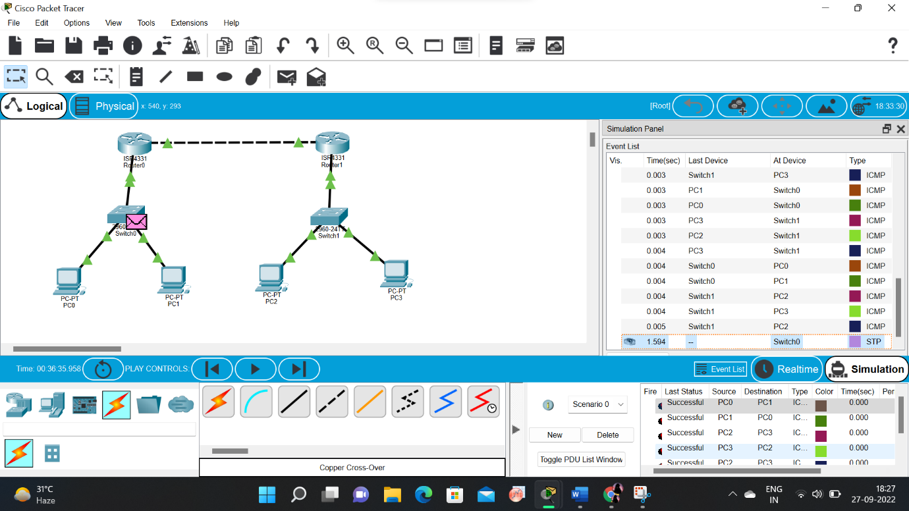

Result:

Static Routing Analysis using Packet Tracer is verified successfully.